**Almamy Aguibou Bah**

**Project 5**

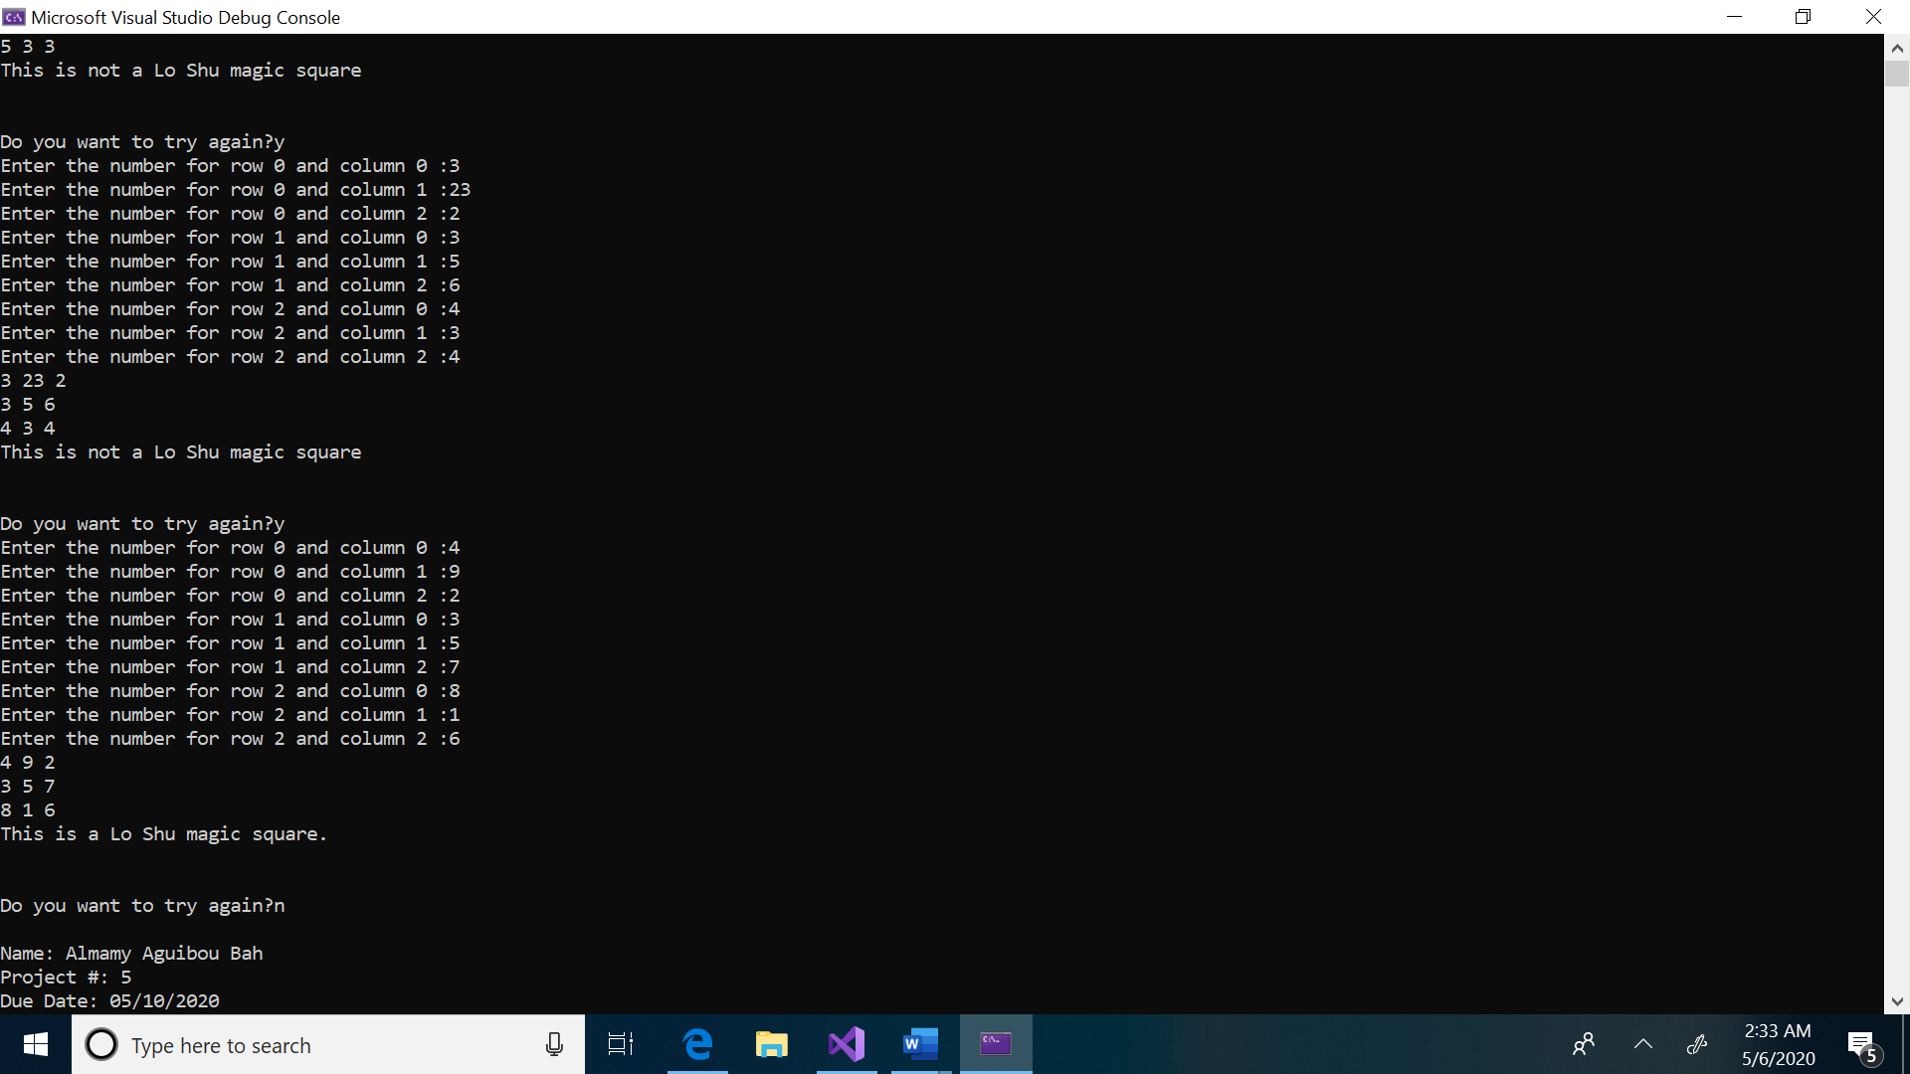

**Test Plan Table**

|  |  |  |  |  |  |
| --- | --- | --- | --- | --- | --- |
| **Test Case #** | **Input** | **Actual Input** | **Expected Output**  **Is Magic?** | **Actual Output**  **Is Magic?** | **Did the test pass?** |
| 1 | 1 3 2  5 4 9  6 7 8 | 1 3 2  5 4 9  6 7 8 | No | No | Yes |
| 2 | 10 2 3  4 15 6  7 8 -8 | 10 2 3  4 15 6  7 8 -8 | No | No | Yes |
| 3 | 4 9 2  3 5 7  8 1 6 | 4 9 2  3 5 7  8 1 6 | Yes | yes | Yes |
| 4 | 4 1 5  7 3 2  12 4 9 | 4 1 5  7 3 2  12 4 9 | No | Yes | Yes |

Lessons learned: They only new thing that I learned while doing this project is how to check if a number is unique between many differents arrays.